Problem​ ​Statement​ ​1:

Find the variance for the following set of data representing trees in California (heights in

feet):

3,​ ​21,​ ​98,​ ​203,​ ​17,​ ​9

Problem Solution:

Formulae:

1. Mean for a sample

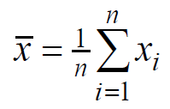

1. Variance for a sample

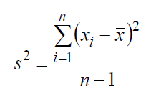

Solution:

Rearranging the given sample in ascending order

3,9,17,21,98,203

Xbar = (3+9+17+21+98+203)/(6-1)

Xbar = 70.2 => Mean

S^2 = ((3-70.2)^2+(9-70.2)^2+(17-70.2)^2+(21-70.2)^2+(98-70.2)^2+(203-70.2)^2)/(6-1)

S^2 = (4515.84+3745.44+2830.24+2420.64+772.84+133.8)/5

S^2 = 2883.76 => Variance